

W1-2-60-1-6

JOMO KENYATTA UNIVERSITY
OF
AGRICULTURE AND TECHNOLOGY

University Examinations 2023/2024

FIRST YEAR SECOND SEMESTER EXAMINATION FOR THE DEGREE OF BACHELOR OF SCIENCE IN COMPUTER SCIENCE

BIT 2111: COMPUTER AIDED DESIGN

DATE: APRIL 2024 TIME: 2 HOURS

INSTRUCTIONS: Answer Question ONE and any other TWO Questions

QUESTION ONE
- A square having coordinates (2,2),( 5,2 ), (5,4) and (2,4) is to be rotated about the point (2,2) in clockwise direction at an angle 60 ͦ and after that it is scaled to 3 units in X direction and 2 units in Y direction. Find the final coordinates of the geometry. [8 Marks]
- Explain how you can use command line option in AutoCAD to draw the following
objects (Show the command structure)
(i) Circle
- Line
- Arc [6 Marks]
- Describe the connection of CAD to computer-aided manufacturing (CAM). How does the CAD/CAM relationship alter the role of 2-D CAD documents? [6 Marks]
- Write a step by step procedure to draw the following figure in AutoCAD or any other software. [10 Marks]
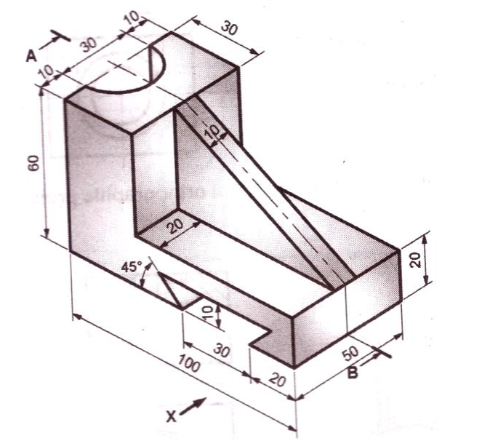

QUESTION TWO
- Define the term layer and explain the importance of layers in a drawing [4 Marks]
- CAD/CAM can be used in concurrent engineering environments. Explain using appropriate examples [6 Marks]
- After you have created some objects in AutoCAD objects that make up a technical drawing, such as lines or circle or a combination of both, they are sometimes just not the way you would like them, they may need to be rotated, moved, copied, scaled larger or smaller, etc., to do these things you need to have a good basic understanding of some of the AutoCAD editing commands. Identify and explain any five such editing commands [10 Marks]

QUESTION THREE
- A triangle PQR has its vertices at P(0,0), Q(4,0) and R(2,3). It is to be translated by 4 units in X direction, and 2 units in Y direction, then it is to be rotated in anticlockwise direction about the new position of point R through 90⁰. Find the final position of the triangle. [8 Marks]
- State with reasons, four factors that may affect a design manager’s choice of a CAD system
for use in his/her department. [4 Marks]
- Compare and contrast the command-based, menu-based and direct manipulation styles of user interface. Which do you feel is the most appropriate to the operation of CAD systems in a window-based environment and why? [8 Marks]

QUESTION FOUR
- Without a Design, Engineering and Manufacturing is impossible. Discuss [4 Marks]
- Using examples, differentiate between Absolute and Relative formats of entering coordinate values in a CAD drawing [6 Marks]
- Illustrate how CAD is used to create product prototypes [6 Marks]
- Illustrate the following methods of drawing arcs and circles in a CAD drawing
- 3 Points
- 2 Tangents and a Point [4 Marks]

